

CAPSTONE PROJECT REPORT
Report 4 – Software Design Document

– Hanoi, August 2019 –

Table of Contents
I. Record of Changes 3
II. Software Design Document 4
1. System Design 4
1.1 System Architecture 4
1.2 Package Diagram 4
2. Database Design 4
3. Detailed Design 5
3.1 <Feature/Function Name1> 5
3.2 <Feature/Function Name2> 6

I. Record of Changes
Date | A*  M, D | In charge | Change Description
*A - Added M - Modified D - Deleted

II. Software Design Document

1. System Design

1.1 System Architecture
LINK
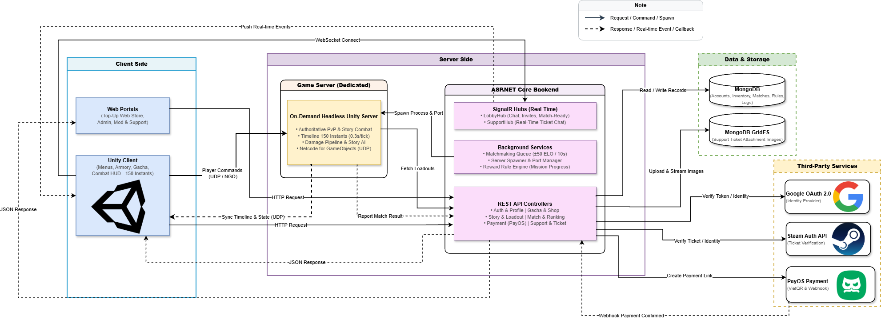

1.2 Package Diagram
[Provide the package diagram for each sub-system. The content of this section includes overall package diagram(s) and the explanation for each package (or namespace). Please see the sample and description table format below]
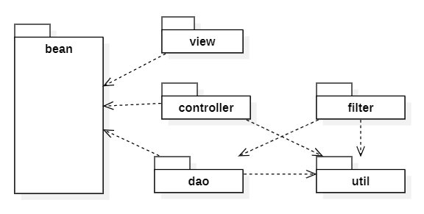
Package Descriptions
No | Package | Description
01 | <Package name> | <Description of the package>
02

2. Database Design
[Provide the files description, database table relationship & table descriptions like example below]
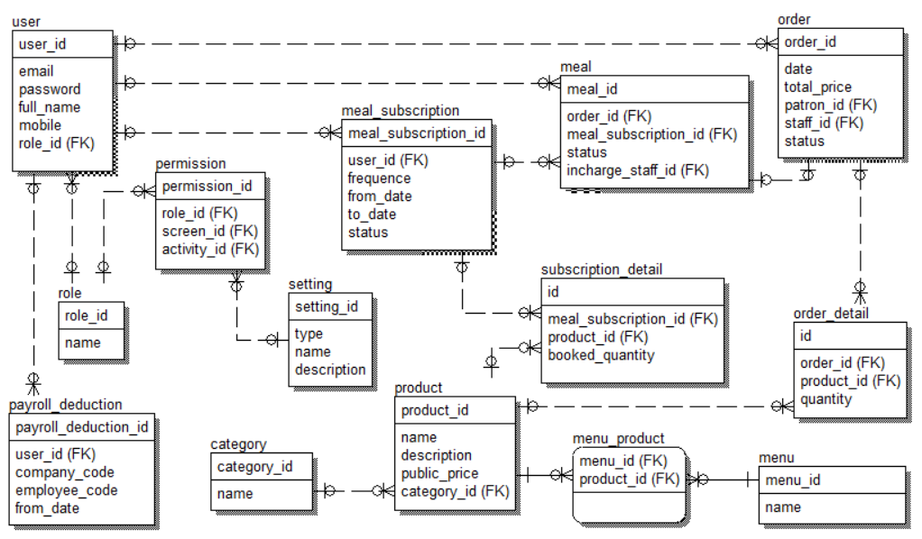
Table Descriptions
No | Table | Description
01 | <Table name> | <Description of the table>  - Primary keys: <<list of primary key fields>>  - Foreign keys: <<list of foreign key fields>>
02 | <Table name2> | …

3. Detailed Design

3.1 <Feature/Function Name1>
[Provide the detailed design for the feature <Feature Name1>. It includes Class Diagram, Class Specifications, and Sequence Diagram(s); For the features/functions with the same structure of class & sequence diagrams, you need to provide the diagrams once for one feature/function and refer to those diagrams from other features/functions]

3.1.1 Class Diagram
[This part presents the class diagram for the relevant feature]
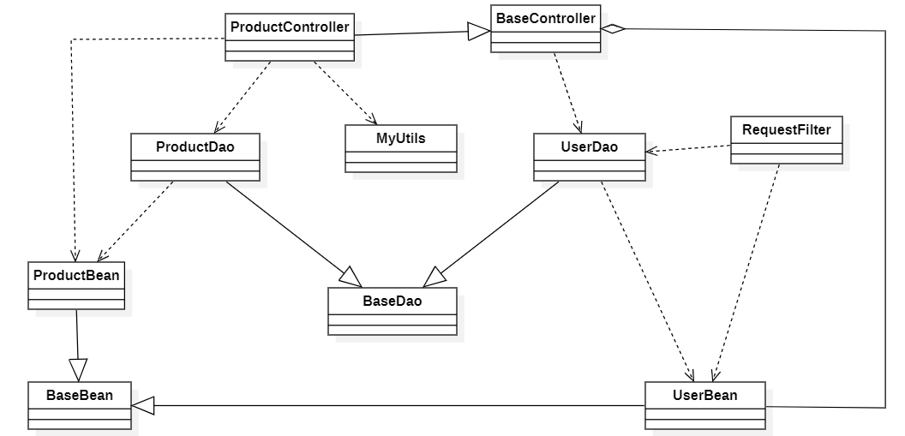
3.1.2 <Sequence Diagram Name1>
[Provide the sequence diagram(s) for the feature, see the sample below]
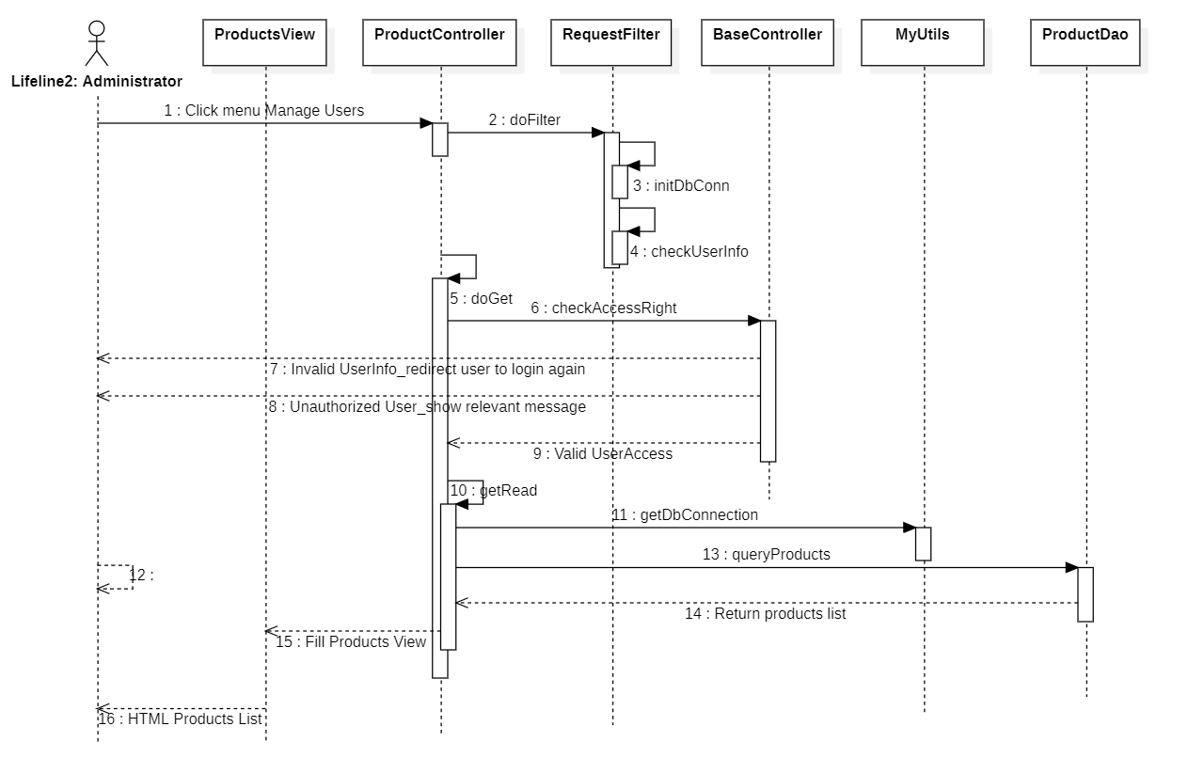

3.1.3 <Sequence Diagram Name2>

3.1.4 …

3.2 <Feature/Function Name2>
…

